Lab Exercise 2
Create an Android App
(Version 2.0)

Author(s):

Mangalaganesh Balasubramanian, GBS BPM & I , Australia
Kaustubh Roy Chowdhury, GBS India
Shri Santhana, GBS Singapore
Manendra Rawat, GBS India
Shahir A. Daya, GBS Cloud CoC
William A Brown, GBS Cloud CoC
Table of Contents

1 Pre-requisites to participate in this lab 3
2 Learning objectives 3
3 Create an Android App 3
3.1 Create a Mobile Cloud application in Bluemix 3
3.2 Create an Android Application 7
3.3 Import artefacts from Example Application 9
3.4 Run the Application 17
References 21

Pre-requisites to participate in this lab
What do you need to participate in this lab? You need an IBM Bluemix account
(https://ng.bluemix.net), the Android Development Toolkit (ADT), and a modern browser like Chrome, Firefox, IE10+ or Safari.

Learning objectives
This lab shows how to create an Android Mobile application and leverage Bluemix as a Mobile Back-end as a Service (MBaaS). The app will use the Mobile Data service that is part of the Mobile Cloud boilerplate to store and retrieve data.
When the lab is completed, your application will be running in an Android Virtual Device (AVD) and will access the Mobile Data service running in Bluemix. You will be able to administer the service using the Bluemix ACE UI.

Create an Android App
In this lab exercise you will create an android application using eclipse that allows you to create and view members in a members list. The data is persisted in a mobile cloud application.

Create a Mobile Cloud application in Bluemix
In this section you will create a Mobile Cloud application in Bluemix that will serve as the mobile back-end for the Android app that you will be creating.
- Login to Bluemix and navigate to your dashboard.
- Click on Create an Application
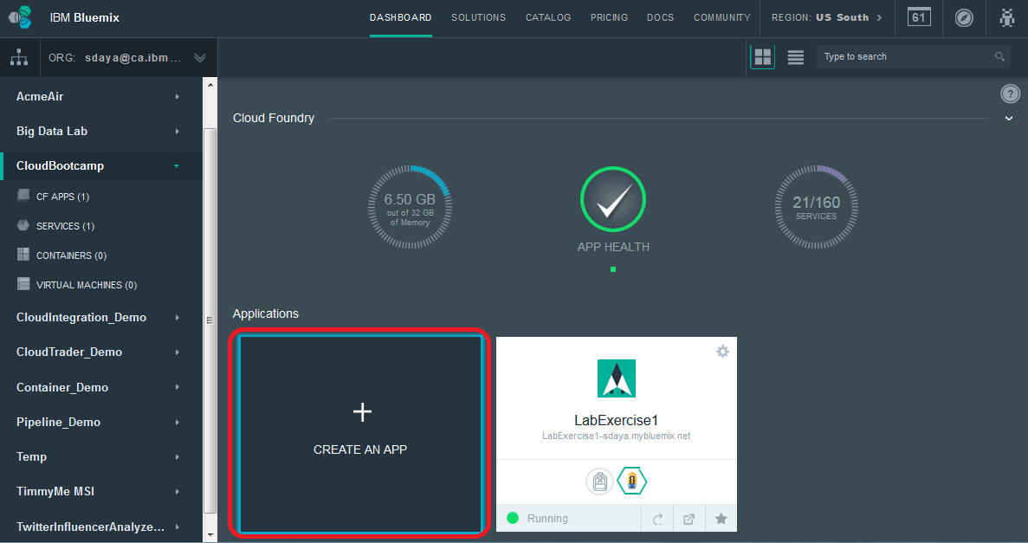
- Click on MOBILE for the kind of app we are creating
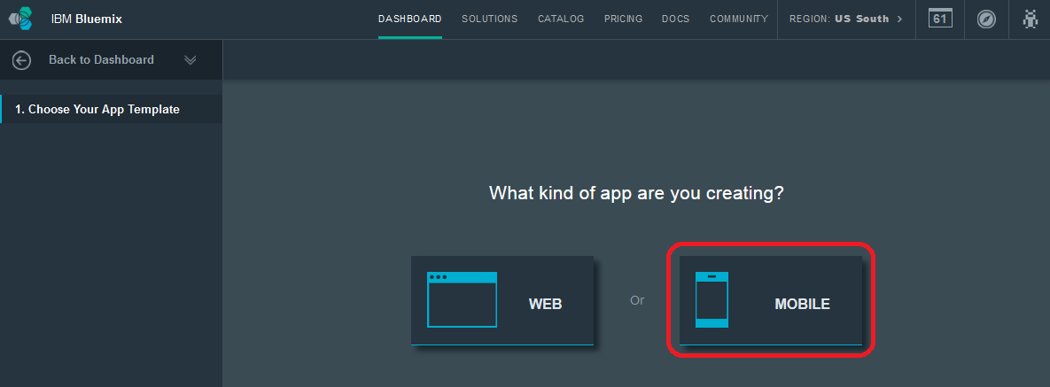
- Click on Mobile (iOS, Android, Hybrid) as the platform
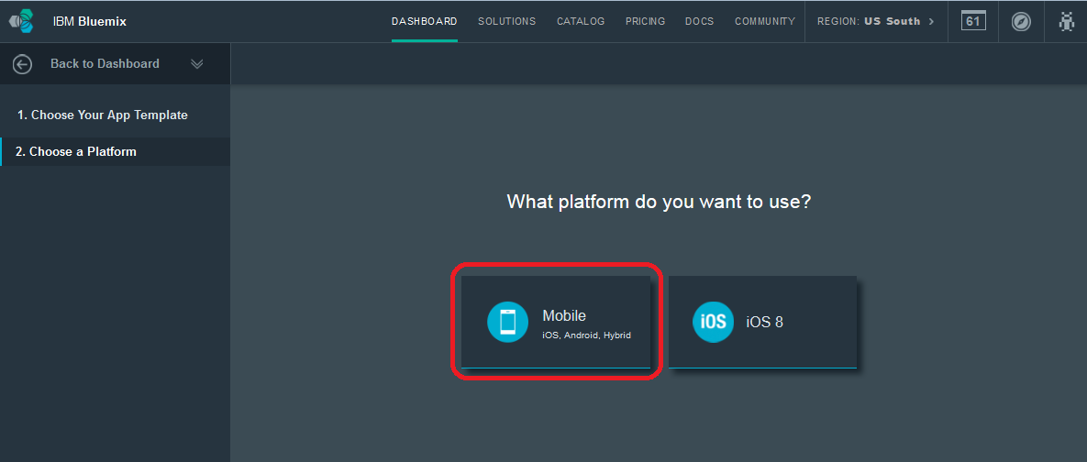
- Click on CONTINUE button
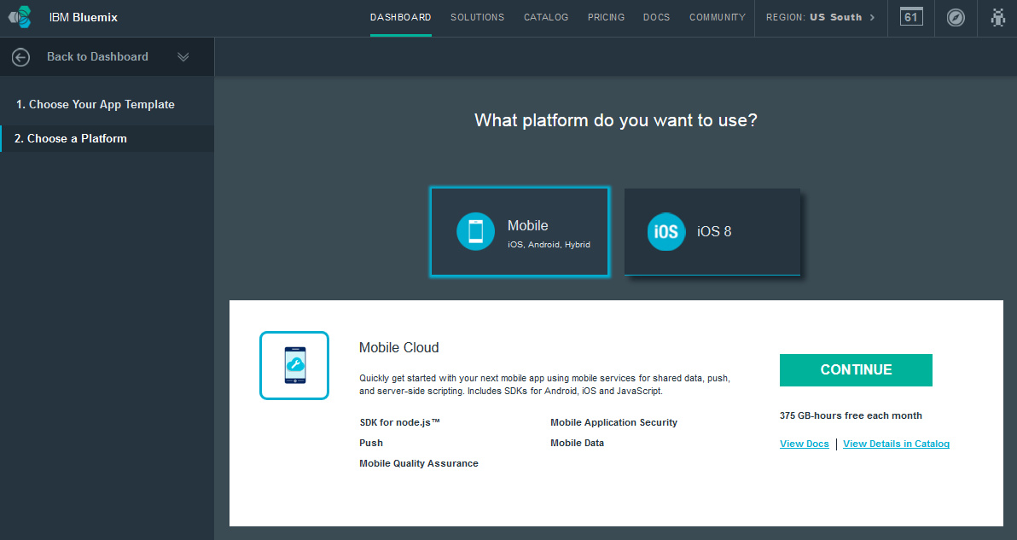
- Give the application a name and click the FINISH button。No name space, LabExercise2-deadlee
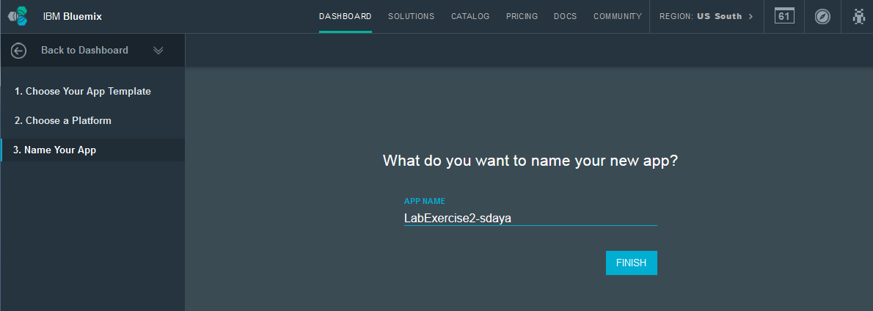
- You will now be presented with a page with details on how to enable your web application for mobile. Click the CONTINUE button after you have read and explored this page.
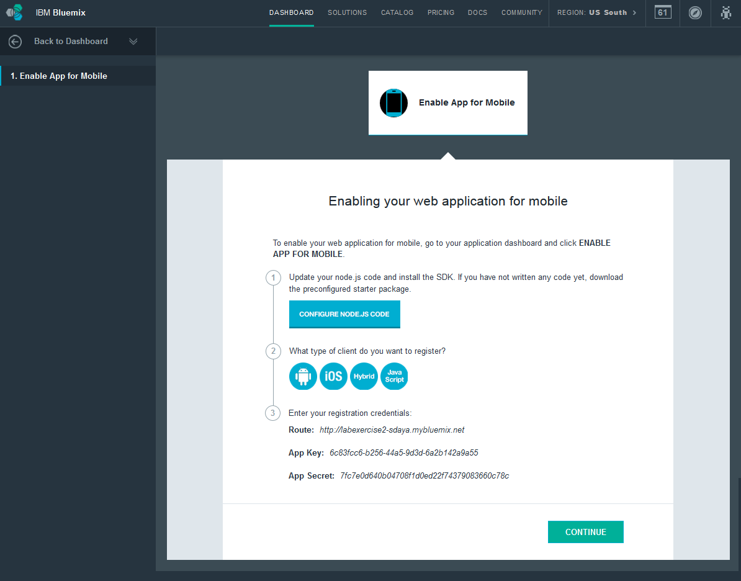

- You will now see the application overview page for your newly created application.
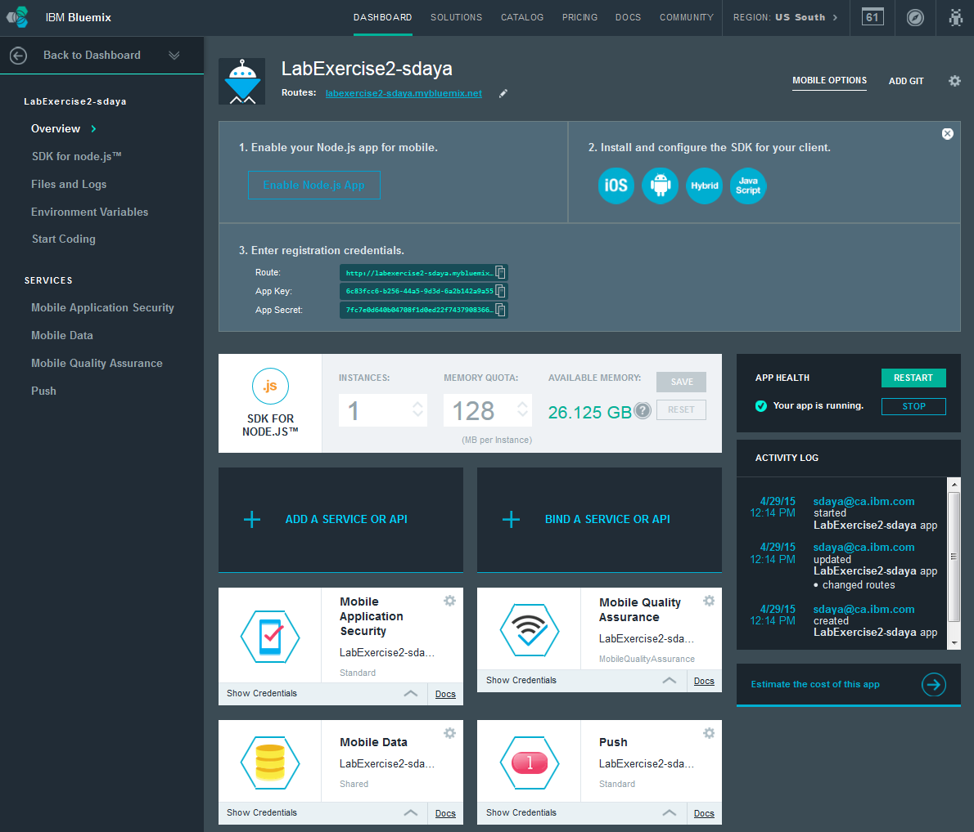
- Click the Back to Dashboard link to go back to the DASHBOARD
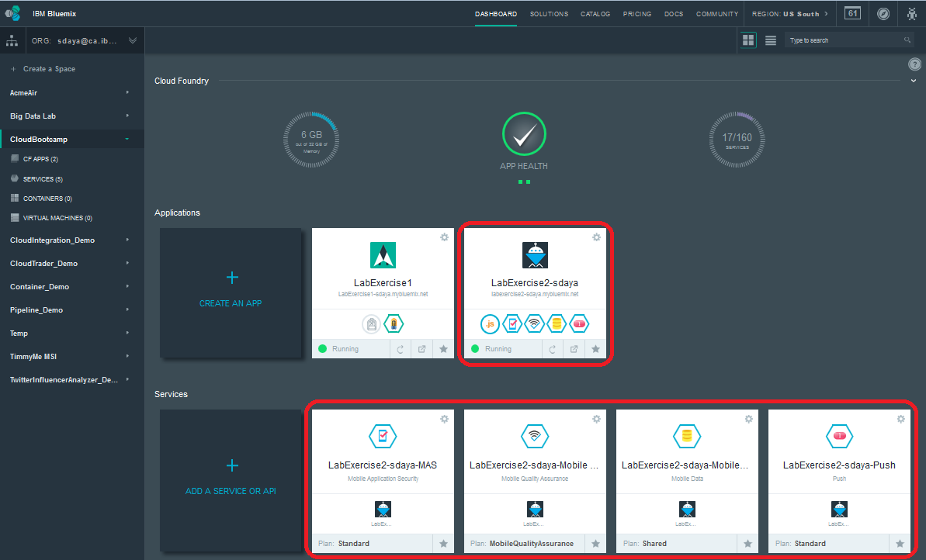

Create an Android Application
In this section you will create an android application using the Android Development Toolkit (eclipse).
- Open Eclipse bundled with the Android SDK
- Create an Android Application
  - Click File → New → Android Application Project
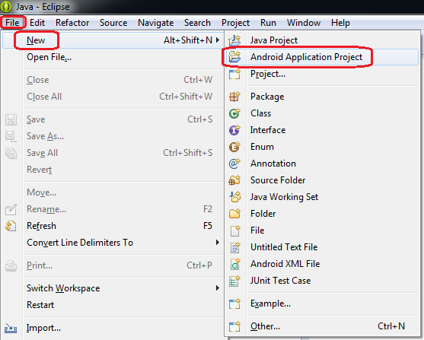
  - Specify the application name as LabExercise2
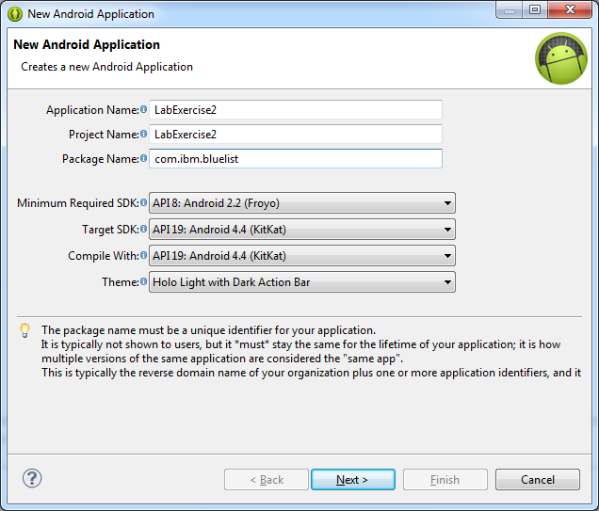
  - Choose com.ibm.bluelist as the package name.
  - Choose API 8: Android 2.2 (Froyo) as the Minimum Required SDK.
  - Choose API 19: Android 4.4 (KitKat) as the Target SDK and the Compile With SDK.
  - Click the Next and accept the defaults to reach the Blank Activity Screen shown below.
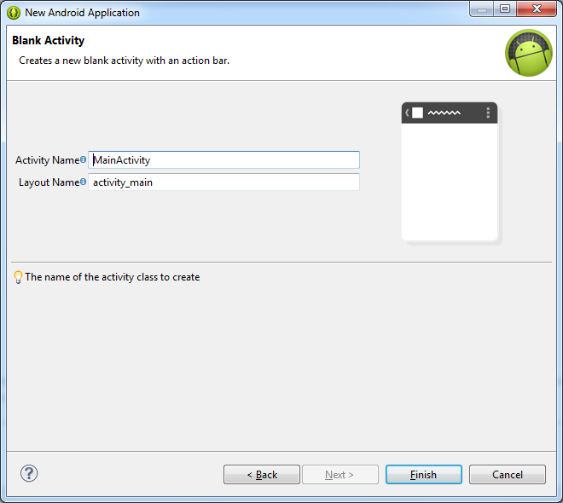
  - Accept the defaults here and then click Finish
A hello world android application is now ready for us to use.
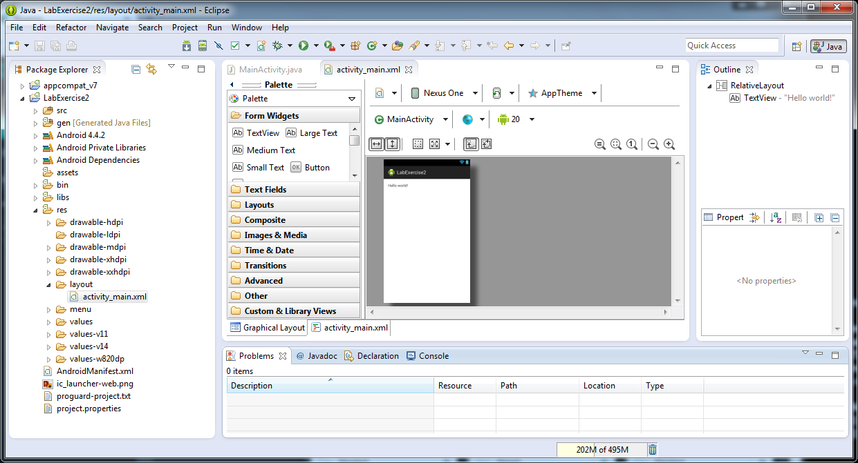

Import artefacts from Example Application
In this section you will import artefacts from the example application - "LabExercise2 - required files - v1.0 08282014.zip" embedded below. A number of default resources are created and we would replace them with the artefacts from this example application.
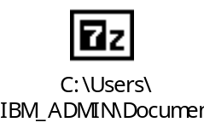
- Turn off Build workspace automatically.
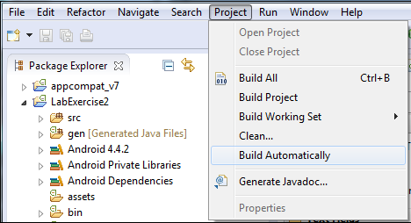
- Extract the zip file into a temporary folder. This folder would be used to copy contents to the eclipse workspace. This folder is herein after referred as "extracted directory"
- Delete the resource folder - "res"
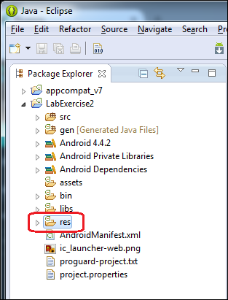
- Copy the "res" folder from the extracted directory to LabExercise2
- Observe that the assets directory is empty.
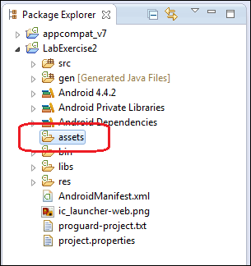
- Copy the file "bluelist.properties" from the extracted directory under assets to the assets directory in LabExercise2.
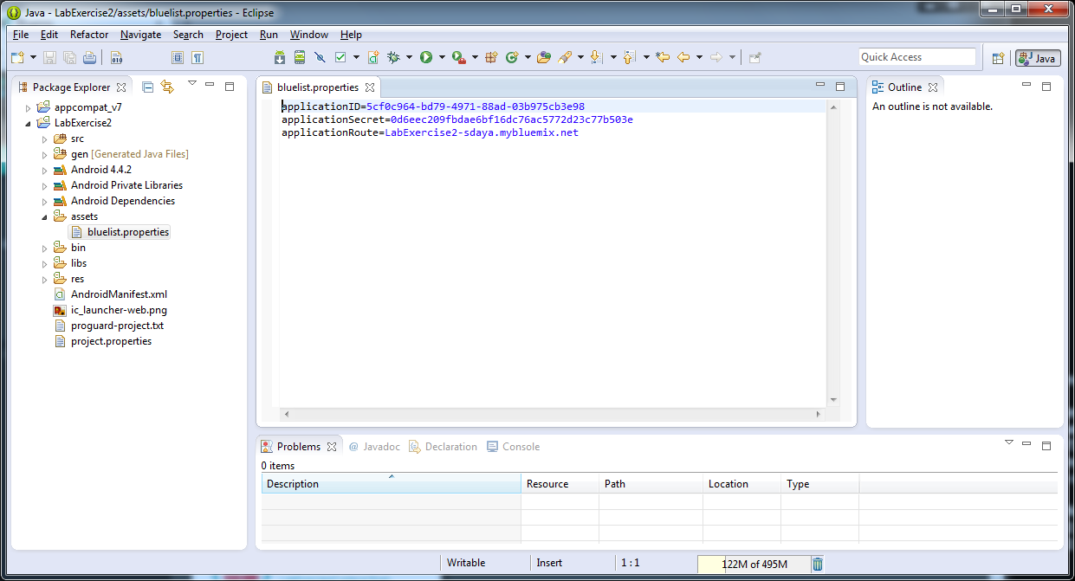
This file contains the App ID, App Secret, and Route that will point the Android app to your Mobile Cloud application running in Bluemix.
- Update the above “bluelist.properties” file with information from your LabExercise2 Mobile Cloud application in Bluemix.
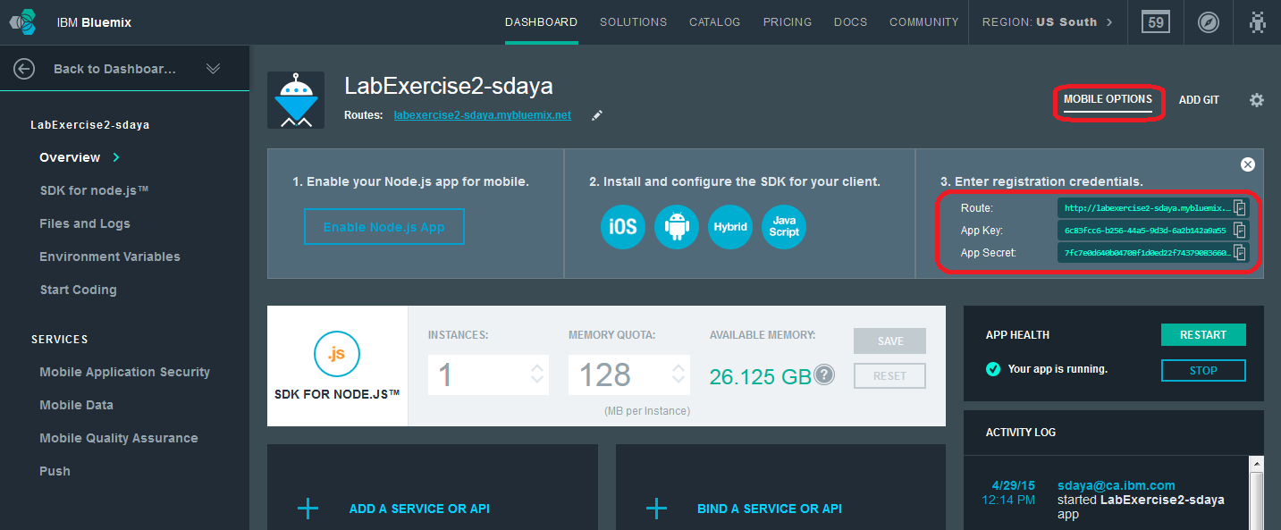
- Open up AndroidManifest.xml file. Delete the contents in the application element. This would be replaced with the contents from the extracted directory.
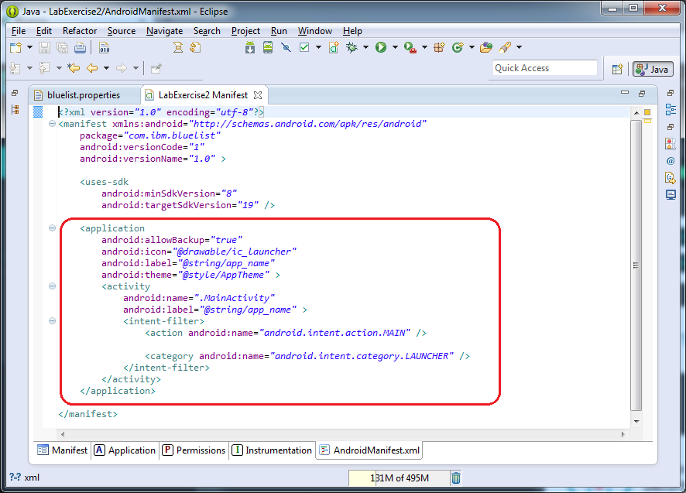
- Copy the following contents. This section contains the permissions as well as the application elements for our demo application.
<!-- Permissions -->
<uses-permission android:name="android.permission.INTERNET" />
<uses-permission android:name="android.permission.WAKE_LOCK" />
<uses-permission android:name="android.permission.GET_ACCOUNTS" />
<uses-permission android:name="android.permission.USE_CREDENTIALS" />
<uses-permission android:name="android.permission.ACCESS_WIFI_STATE" />

<application
android:name=".BlueListApplication"
android:allowBackup="true"
android:icon="@drawable/logo"
android:label="@string/app_name"
android:theme="@style/AppTheme" >

<activity
android:name="com.ibm.bluelist.CreateEmp"
android:label="@string/app_name" >
<intent-filter>
<action android:name="android.intent.action.MAIN" />
<category android:name="android.intent.category.LAUNCHER" />
</intent-filter>
</activity>
<activity
android:name="com.ibm.bluelist.MainActivity"
android:label="@string/app_name" >
</activity>
<activity
android:name="com.ibm.bluelist.EditActivity"
android:label="@string/title_activity_edit" >
</activity>
</application>
- Expand the libs directory and observe that it contains a single jar - android-support-v4.jar
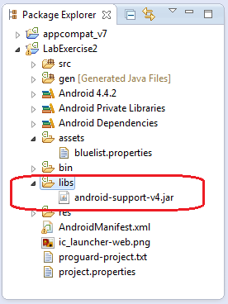
- Download the Bluemix Mobile SDK. You can get to the download from within your Mobile Cloud application in Bluemix.
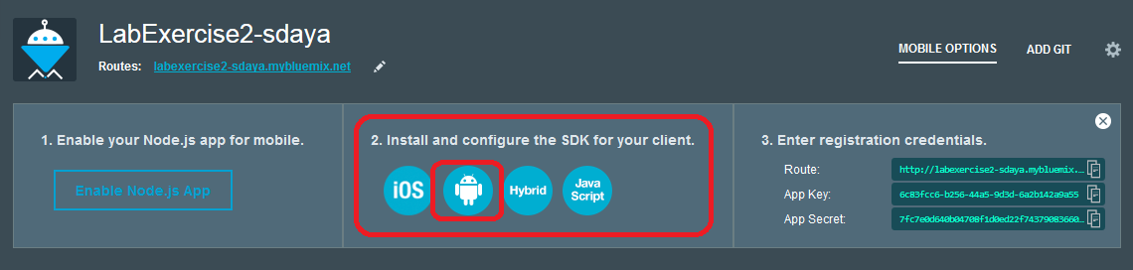
- Look for the section that provides details to add the Mobile Cloud Services SDK to your Android project. Follow those instructions.
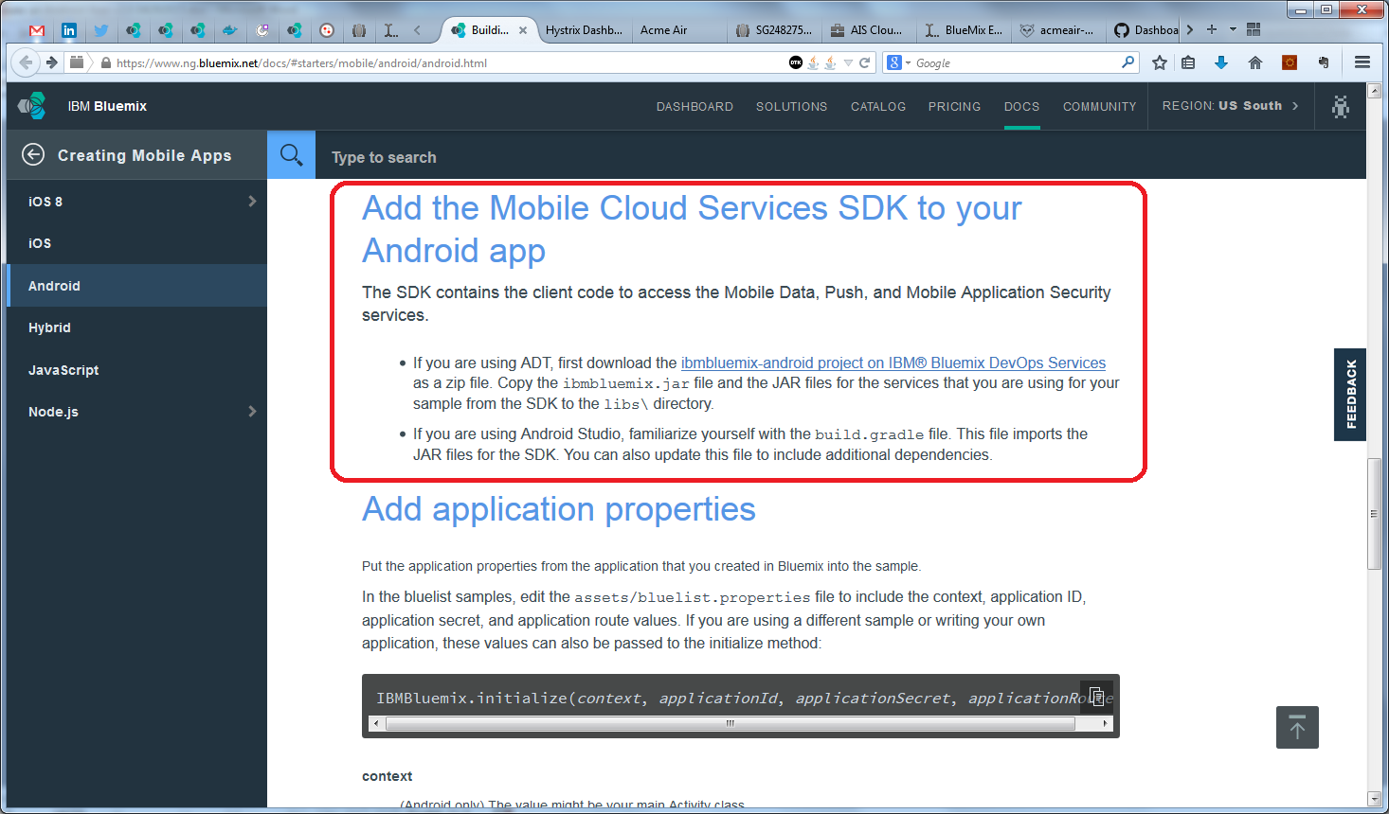
- Download the following JAR files:
  - ibmbluemix.jar
  - ibmpush.jar
  - ibmdata.jar
  - ibmfilesync.jar
  - ibmcloudcode.jar
  - ibmlocation.jar
from https://hub.jazz.net/project/bluemixmobilesdk/ibmbluemix-android/overview. See the Contents sections for links to the individual repositories for these files.

- Copy the JAR files to the libs directory in LabExercise2.
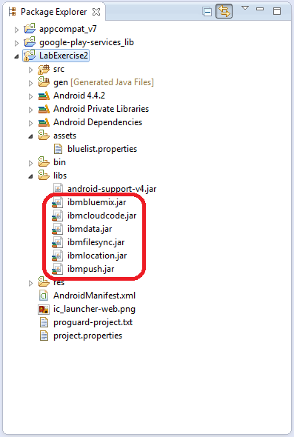
- Examine the src folder. Notice that it contains a single class - MainActivity.java
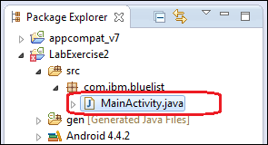
- From the extracted directory, locate the "src/com/ibm/bluelist" folder and pick all the java files and copy them to the com.ibm.bluelist package under src in the workspace.
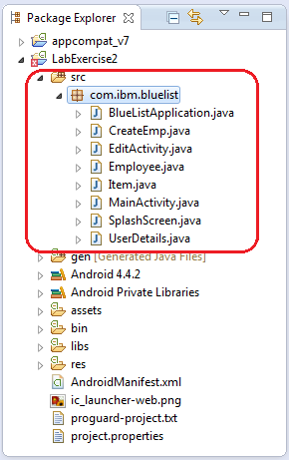
- Accept when you are asked to overwrite the existing MainActivity.java file.
- Clean and build the entire workspace. Ensure that there aren't any errors in both the console and problems view.
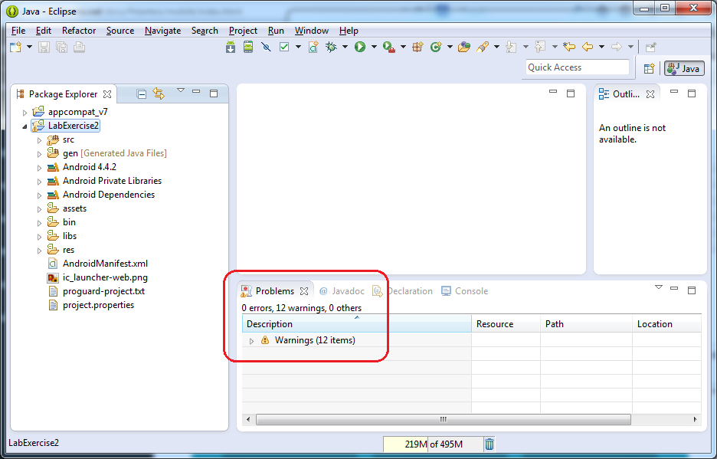

Run the Application
- Run the application as an Android App. Select the MobileDemoApp. Using the context menu, choose Run As → Android Application
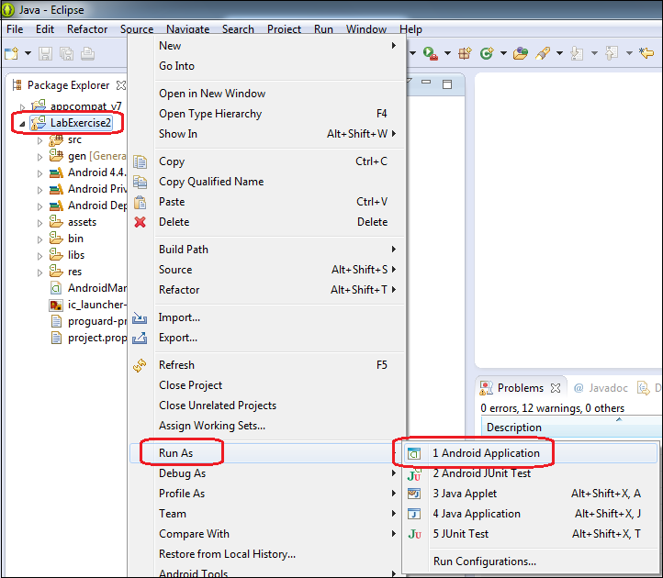
- If an Auto Monitor Logcat window pop up opens up, choose the priority as "verbose" to ensure that we get to see what is happening under the hood in the logcat view.
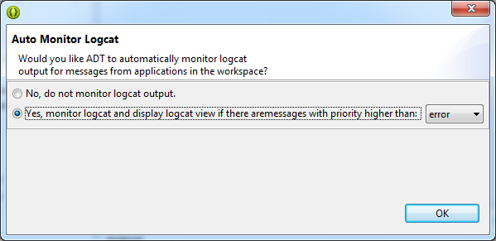
- The emulator starts up. The EmpReport application should open up. This typically takes a couple of minutes on most machines.
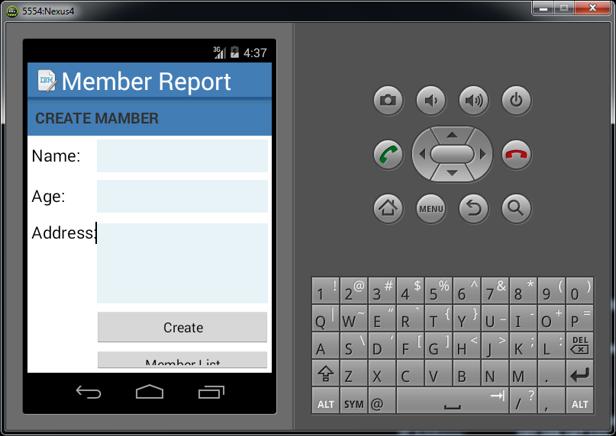
- Enter name, age and address and click "Create"
- The list of members should show up. If it does not, click on Member List
- The list of members would look like the figure below
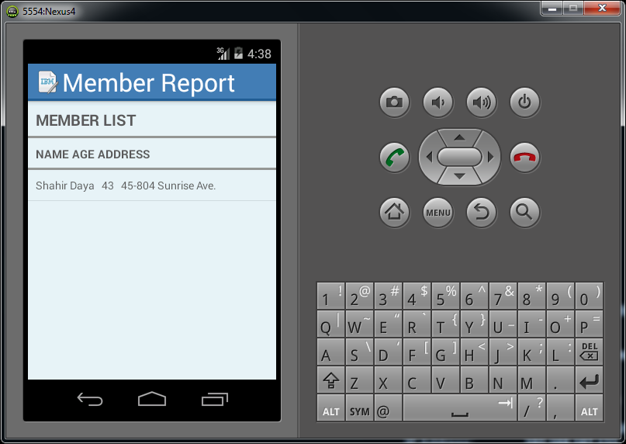
You will find that the member information is stored in the cloud in the Mobile Data service.
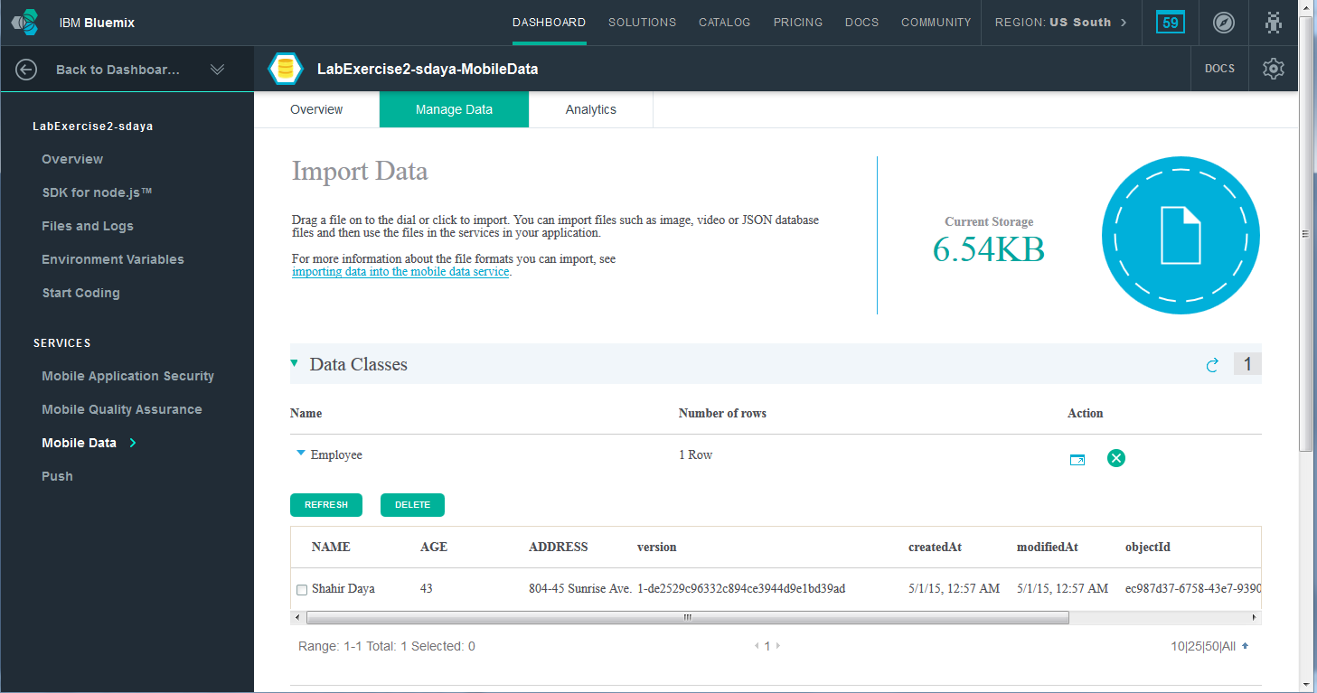
The Mobile Data service also provides an Analytics view as shown below.
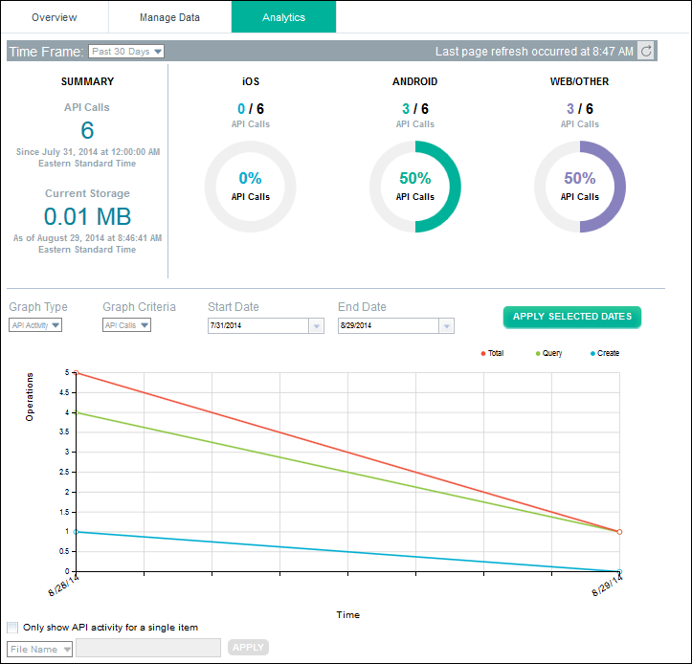
In this exercise you created a Mobile Cloud app on Bluemix. You created an Android application using eclipse that worked with the Mobile Cloud on Bluemix to store its member information.

References
- Building a mobile application, (2014). IBM Bluemix Docs. [online] Available at: https://www.ng.bluemix.net/docs/#starters/BuildingMobile.html [Accessed 28 Aug. 2014].
- Installing the Android SDK, (2014). Installing the Android SDK | Android Developers. [online] Developer.android.com. Available at: https://developer.android.com/sdk/installing/index.html?pkg=adt [Accessed 28 Aug. 2014].
- Setting Up Google Play Services, (2014). Setting Up Google Play Services | Android Developers. [online] Developer.android.com. Available at: http://developer.android.com/google/play-services/setup.html [Accessed 28 Aug. 2014].

END OF DOCUMENT

